CHAPTER -1

**INTRODUCTION**

**1.1 Introduction**

This project is aimed at developing an online search Portal for the Placement Details for job seekers. The system is an online application that can be accessed throughout the organization and outside as well with proper login provided. This system can be used as an Online Job Portal for job seekers. Job Seekers logging should be able to upload their information in the form of a CV. Visitors/Company representatives logging in may also access/search any information put up by Job aspirants.

Websites have many functions and can be used in various fashions; a website can be a [personal website](https://en.wikipedia.org/wiki/Personal_website), a commercial website for a company, a [government website](https://en.wikipedia.org/wiki/E-Government) or a [non-profit organization](https://en.wikipedia.org/wiki/Nonprofit_organization) website. Websites can be the work of an individual, a business or other organization, and are typically dedicated to a particular topic or purpose, ranging from entertainment and [social networking](https://en.wikipedia.org/wiki/Social_networking) to providing news and education. All publicly accessible websites collectively constitute the [World Wide Web](https://en.wikipedia.org/wiki/World_Wide_Web), while private websites, such as a company's website for its employees, are typically a part of an [intranet](https://en.wikipedia.org/wiki/Intranet).

[Web pages](https://en.wikipedia.org/wiki/Web_page), which are the [building blocks](https://en.wikipedia.org/wiki/Building_block) of websites, are [documents](https://en.wikipedia.org/wiki/Document), typically composed in [plain text](https://en.wikipedia.org/wiki/Plain_text) interspersed with formatting instructions of Hypertext Markup Language ([HTML](https://en.wikipedia.org/wiki/HTML), [XHTML](https://en.wikipedia.org/wiki/XHTML)). They may incorporate elements from other websites with suitable [mark-up anchors](https://en.wikipedia.org/wiki/HTML_anchor). Web pages are accessed and transported with the [Hypertext Transfer Protocol](https://en.wikipedia.org/wiki/Hypertext_Transfer_Protocol) (HTTP), which may optionally employ encryption ([HTTP Secure](https://en.wikipedia.org/wiki/HTTP_Secure), HTTPS) to provide security and privacy for the user. The user's application, often a [web browser](https://en.wikipedia.org/wiki/Web_browser), renders the page content according to its HTML markup instructions onto a [display terminal](https://en.wikipedia.org/wiki/Computer_monitor).

[Hyper linking](https://en.wikipedia.org/wiki/Hyperlink) between web pages conveys to the reader the [site structure](https://en.wikipedia.org/wiki/Site_map) and guides the navigation of the site, which often starts with a [home page](https://en.wikipedia.org/wiki/Home_page) containing a directory of the site [web content](https://en.wikipedia.org/wiki/Web_content). Some websites require user registration or [subscription](https://en.wikipedia.org/wiki/Subscription) to access content. Examples of [subscription websites](https://en.wikipedia.org/wiki/Paywall) include many business sites, parts of news websites, [academic journal](https://en.wikipedia.org/wiki/Academic_journal) websites, gaming websites, file-sharing websites, [message boards](https://en.wikipedia.org/wiki/Internet_forum), web-based [email](https://en.wikipedia.org/wiki/Email), [social networking](https://en.wikipedia.org/wiki/Social_networking) websites, websites providing real-time [stock market](https://en.wikipedia.org/wiki/Stock_market) data, as well as sites providing various other services. As of 2016 [end users](https://en.wikipedia.org/wiki/End_user) can access websites on a range of devices , including desktop and laptop, computers, [smartphones](https://en.wikipedia.org/wiki/Smartphone) and [smart TVs](https://en.wikipedia.org/wiki/Smart_TV).

Websites have many functions and can be used in various fashions; a website can be a personal website, a commercial website, a government website or a non-profit organization website. Websites can be the work of an individual, a business or other organization, and are typically dedicated to a particular topic or purpose. Any website can contain a hyperlink to any other website, so the distinction between individual sites, as perceived by the user, can be blurred. Websites are written in, or converted to, HTML (Hyper Text Markup Language) and are accessed using a software interface classified as a user agent. Web pages can be viewed or otherwise accessed from a range of computer-based and Internet-enabled devices of various sizes, including desktop computers, laptops, PDAs and cell phones. A website is hosted on a computer system known as a web server, also called an HTTP server. These terms can also refer to the software that runs on these systems which retrieves and delivers the web pages in response to requests from the website's users. Apache is the most commonly used web server software (according to Netcraft statistics) and Microsoft's IIS is also commonly used. Some alternatives, such as Nginx, Lighttpd, Hiawatha or Cherokee, are fully functional and lightweight.

There are two types of website and they are as follows

* **Static Website**

A static website is one that has web pages stored on the server in the format that is sent to a client web browser. It is primarily coded in [Hypertext Markup Language](https://en.wikipedia.org/wiki/Hypertext_Markup_Language) (HTML); [Cascading Style Sheets](https://en.wikipedia.org/wiki/Cascading_Style_Sheets) (CSS) are used to control appearance beyond basic HTML. Images are commonly used to effect the desired appearance and as part of the main content. Audio or video might also be considered "static" content if it plays automatically or is generally non-interactive. This type of website usually displays the same information to all visitors. Similar to handing out a printed brochure to customers or clients, a static website will generally provide consistent, standard information for an extended period of time. Although the website owner may make updates periodically, it is a manual process to edit the text, photos and other content and may require basic website design skills and software. Simple forms or marketing examples of websites, such as classic website, a five-page website or a brochurewebsite are often static websites, because they present pre-defined, static information to the user. This may include information about a company and its products and services through text, photos, animations, audio/video, and navigation menus.

Static websites may still use [server side includes](https://en.wikipedia.org/wiki/Server_side_include) (SSI) as an editing convenience, such as sharing a common menu bar across many pages. As the site's behaviour to the reader is still static, this is not considered a dynamic site.

* **Dynamic Website**

A dynamic website is one that changes or customizes itself frequently and automatically. Server-side dynamic pages are generated "on the fly" by computer code that produces the HTML (CSS are responsible for appearance and thus, are static files). There are a wide range of software systems, such as [CGI](https://en.wikipedia.org/wiki/Common_Gateway_Interface), [Java Servlets](https://en.wikipedia.org/wiki/Java_Servlets) and [Java Server Pages](https://en.wikipedia.org/wiki/Java_Server_Pages) (JSP), [Active Server Pages](https://en.wikipedia.org/wiki/Active_Server_Pages)  and  [ColdFusion](https://en.wikipedia.org/wiki/ColdFusion)  (CFML) that are available to generate [dynamic web systems and dynamic sites](https://en.wikipedia.org/wiki/Programming_languages_used_in_most_popular_websites). Various [web application frameworks](https://en.wikipedia.org/wiki/Web_application_framework) and [web template systems](https://en.wikipedia.org/wiki/Web_template_system) are available for general-use [programming languages](https://en.wikipedia.org/wiki/Programming_language) like [Perl](https://en.wikipedia.org/wiki/Perl), [PHP](https://en.wikipedia.org/wiki/PHP), [Python](https://en.wikipedia.org/wiki/Python_(programming_language)) and [Ruby](https://en.wikipedia.org/wiki/Ruby_(programming_language)) to make it faster and easier to create complex dynamic websites.

A site can display the current state of a dialogue between users, monitor a changing situation, or provide information in some way personalized to the requirements of the individual user. For example, when the front page of a news site is requested, the code running on the web server might combine stored HTML fragments with news stories retrieved from a [database](https://en.wikipedia.org/wiki/Database) or another website via [RSS](https://en.wikipedia.org/wiki/RSS) to produce a page that includes the latest information. Dynamic sites can be interactive by using [HTML forms](https://en.wikipedia.org/wiki/HTML_forms), storing and reading back [browser cookies](https://en.wikipedia.org/wiki/Browser_cookies), or by creating a series of pages that reflect the previous history of clicks. Another example of dynamic content is when a retail website with a database of media products allows a user to input a search request, e.g. for the keyword [Beatles](https://en.wikipedia.org/wiki/Beatles). In response, the content of the web page will spontaneously change the way it looked before, and will then display a list of Beatles products like CDs, DVDs and books. [Dynamic HTML](https://en.wikipedia.org/wiki/Dynamic_HTML) uses [JavaScript](https://en.wikipedia.org/wiki/JavaScript) code to instruct the web browser how to interactively modify the page contents. One way to simulate a certain type of dynamic website while avoiding the performance loss of initiating the dynamic engine on a per-user or per-connection basis, is to periodically automatically regenerate a large series of static pages.

**1.2 Necessity:**

The existing system includes the static website which has no dynamic work in the website and not including the details of jobs. This creates the load of work in the job portal to provide the details information of jobs and also get every job information by slowly.

* Existing system are a failing in providing quick operation
* Cost is high as well.
* Processing very lengthy and time consuming.
* More time consume for before generation

There is no CSS works or animated Parts in the existing system which generally like by the users. The existing system contains there is no photo gallery the website requires very less number of Information as compare to the other website.

In the existing system there is no student feedback part in the website. The website does not contain any registration part for the Students. It can store information dynamically and due to that part the system does not contain any part which is done dynamically

**1.3 Objectives and Themes:**

* This system can be used as an Online Job Portal for the Placements providing to the un employees who are seeking for a job placement.
* Job Seeker logging into the system and he can should be able to upload their information in the form of a CV. Visitors/Company representatives logging in may also access/search any information put up by JobSeeker.
* In other words

1. Simple database is maintained.
2. Easy operation for the operator of the system.
3. Faster Execution & maintaining the records.
4. User interface are user friendly and attractive, it takes very less time for the operator to get use to with the system.

**1.5 Organization:**

Using this project organization user can interact with the system easily. There is no need of special training for understanding the system. Even administrator also does not need of any special training for using system. System is designed such a way layman can also use the system very efficiently. Administrator can access and store the information about the data easily. The System Study section gives details on ideas and concepts that the framework builds upon. It also details about html and PHP, which is the operating environment, its specifications and different libraries which are incorporated in the application design.

The System Design shows a few system modeling diagrams in Unified Modeling Language (UML).

## CHAPTER -2

**LITERATURE SURVEY**

The literature survey of the project defined as the project is design in the home tab is to make modules in the tabs and they also include other information such as company details and there is also automatic image which side the images in the home screen.

This also includes the about us tab that contains some unique characteristics of information which contains the information of the job, company, skills etc. There is also a Infrastructure tab that includes the infrastructure information of the company that does not include any such relevant information of the company.

The administrative user interface concentrates on the consistent information that is practically, part of the organizational activities and which needs proper authentication for the data collection. The interfaces help the administrations with all the transactional states like Data insertion, Data deletion and Date updating along with the extensive data search capabilities.

The operational or generic user interface helps the users upon the system in transactions through the existing data and required services. The operational user interface also helps the ordinary users in managing their own information helps the ordinary users in managing their own information in a customized manner as per the assisted flexibilities.

The main part of the system will be the administrator panel that can only handle the website. And the website which can be handled by the principal of the college. There is also a website which will be done in PHP, HTML, and SQL for Database server. The system is having a good css design and also JavaScript will be used.

**2.1Features of PHP:**

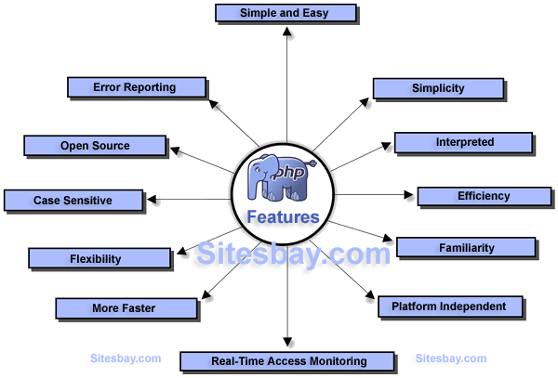

***Fig 2.1. features of PHP***

**2.2.Drawback of other language:**

1. JSP execution requires more time since it is translated into Servlet, compiled and executed whereas PHP execution requires less time than JSP
2. JSP execution requires a servlet container like Tomcat since it is a servlet in disguise whereas PHP can run on its own as a CGI engine.
3. Mastering [JSP requires knowledge of Java](https://www.educba.com/jsp-vs-javascript/) and HTML syntax whereas PHP being a scripting language is easier to learn and understand.
4. PHP provides more freedom to code and work as it is open source. In.Net, freedom is limited as we have to use visual studio IDE only to develop.
5. PHP is free of cost. .Net is Microsoft product and needs to buy the license to use that product. To use .net, it requires to buy windows as well and it is expensive for most of the people.

**2.3 Information about PHP:**

* PHP is a recursive acronym for "PHP: Hypertext Preprocessor".
* PHP is a server side scripting language that is embedded in HTML. It is used to manage dynamic content, databases, session tracking, even build entire e-commerce sites.
* It is integrated with a number of popular databases, including MySQL, PostgreSQL, Oracle, Sybase, Informix, and Microsoft SQL Server.
* PHP is pleasingly zippy in its execution, especially when compiled as an Apache module on the Unix side. The MySQL server, once started, executes even very complex queries with huge result sets in record-setting time.
* PHP supports a large number of major protocols such as POP3, IMAP, and LDAP. PHP4 added support for Java and distributed object architectures (COM and CORBA), making n-tier development a possibility for the first time.
* PHP is forgiving: PHP language tries to be as forgiving as possible.
* PHP Syntax is C-Like.

**2.4 Uses and Characteristics**

* PHP performs system functions, i.e. from files on a system it can create, open, read, write, and close them.
* PHP can handle forms, i.e. gather data from files, save data to a file, through email you can send data, return data to the user.
* You add, delete, modify elements within your database through PHP.
* Access cookies variables and set cookies.
* Using PHP, you can restrict users to access some pages of your website.
* It can encrypt data.

Five important characteristics make PHP's practical nature possible −

* Simplicity
* Efficiency
* Security
* Flexibility
* Familiarity

**2.5 Requirement specification**

**2.5.1Hardware Specifications**

PROCESSOR : PENTIUM Core 2 duo

PROCESSOR SPEED : 2.4GHZ

RAM : 1 GB

KEYBOARD & MOUSE : STANDARD KEYBOARD & MOUSE

HARD DISK : 80 GB

MONITOR : LCD

**2.5.2 Software Specification**

OPERATING SYSTEM : WINDOWS7

FRONT END : HTML

BACK END : MYSQL

SERVER LANGUAGE : PHP 5.3.0

WEB SERVER : XAMPP SERVER

WEB BROWSER : GOOGLE CHROME/ MOZILLA FIREFOX

## CHAPTER -3

**SYSTEM IMPLEMENTATION PLAN**

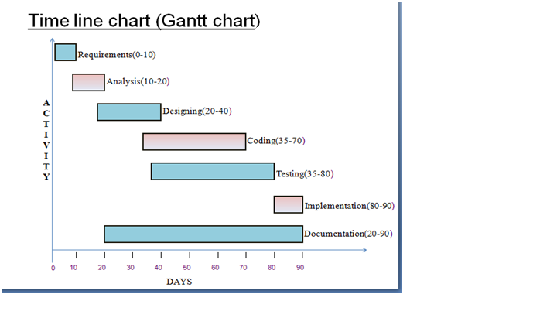

*Fig.3.1.Timeline chart*

A Timeline is a way of displaying lists of events in Chronological order, sometimes described as project artifacts. It is typically a graphics design showing a long bar labeled with dates alongside itself and usually events.

Timelines are often used in education to help students and researchers with understanding the order or chronology of historical events and trends for a subject.

CHAPTER -4

**SOFTWARE DESIGN**

System Design is the solution to the creation of the new system. This phase is composed of several systems. This phase focuses on the detailed implementation of the feasible system. It emphasis on translating design specifications to performance specification. System Design has two phases of development i.e. logical and physical design.

During a logical Design phase the analyst describes input (sources), output (destination), databases (data stores) and procedures (data flows) all in a format that meets the uses requirements. The analyst also specifies the user needs and at a level that virtually determines the information flow in and out of the system and the data resources. Here the logical design is done through data flow diagrams and database design. The physical design is followed by physical design and coding. Physical design produces the working system by defining the design specifications, which tells the programmers what the candidate system can do. The programmers write the program that accept input from user, perform necessary accepted data through call and produce the report on a hard copy or display it on the screen.

**4.1 System Architecture**

System architecture is a conceptual model that defines the structure, behaviour, and more views of a system. An architecture description is a formal description and representation of a system, organized in a way that supports reasoning about the structures and behaviours of the system.

A system architecture can comprise system components that will work together to implement the overall system. There have been efforts to formalize languages to describe system architecture, collectively these are called architecture description languages  (ADLs).

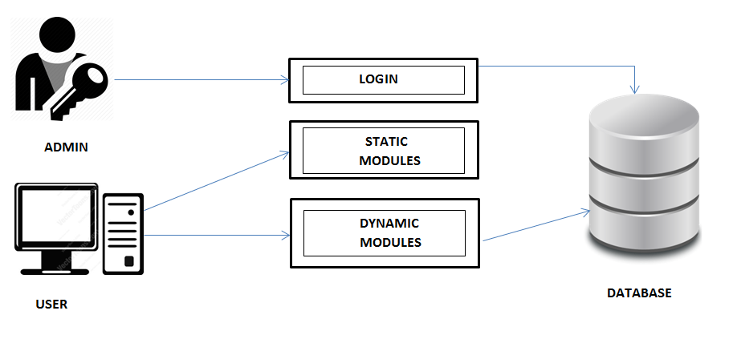

***Fig.4.1.1System Architecture***

**4.1.2NUMBER OF MODULES**

The system after careful analysis has been identified to be presented with the following modules:

The modules involved are:

* + - Admin
    - JobSeeker
    - JobProvider
    - Notification
    - Search
    - Report
    - Authentication

**Admin**

In this module Admin will add all the qualifications, skill, experience, city, state, country and update and delete information about the job provider or job seeker he can also search for the job seeker and he can send mail to offer the job to job seeker and he can also see the jobs add by the job provider.

**Job Seeker**

In this module Job Seeker register him self and upload his resume and fill the profile give by admin and after login he will search for the job on various conditions and he can change his profiles and resume and he can apply for the jobs based on various conditions. He can see the response of the company and he can call the company person for the interview.

**Job provider**

In this module Job Provider register him self and his company and after login he will add new job and he can search for the job seekers on various condition and he can offer the job to job seeker according to the job profile and he can also see the response from the job seekers and send the mail.

**Notification**

In this module admin and job provider send the notification to the job seeker in the form of email.

**Reports:-**

This module contains all the information about the reports generated by the admin based on the particular job seeker, particular job provider, all job seeker and job provider, all jobs generated by the job providers.

Authentication:-This module contains all the information about the authenticated user. User without his username and password can’t enter into the login if he is only the authenticated user then he can enter to his login.

**4.2 Analysis Model**

This document play a vital role in the development of life cycle (SDLC) as it describes the complete requirement of the system. It means for use by developers and will be the basic during testing phase. Any changes made to the requirements in the future will have to go through formal change approval process.

SPIRAL MODEL was defined by Barry Boehm in his 1988 article, “A spiral Model of Software Development and Enhancement. This model was not the first model to discuss iterative development, but it was the first model to explain why the iteration models.

As originally envisioned, the iterations were typically 6 months to 2 years long. Each phase starts with a design goal and ends with a client reviewing the progress thus far. Analysis and engineering efforts are applied at each phase of the project, with an eye toward the end goal of the project.

**4.2.1 ER Diagram**

An Entity Relationship Diagram (ERD) is a visual representation of different data using conventions that describe how these data are related to each other. For example, the elements writer, novel, and consumer may be described using ER diagrams this way: ER diagram with basic objects.

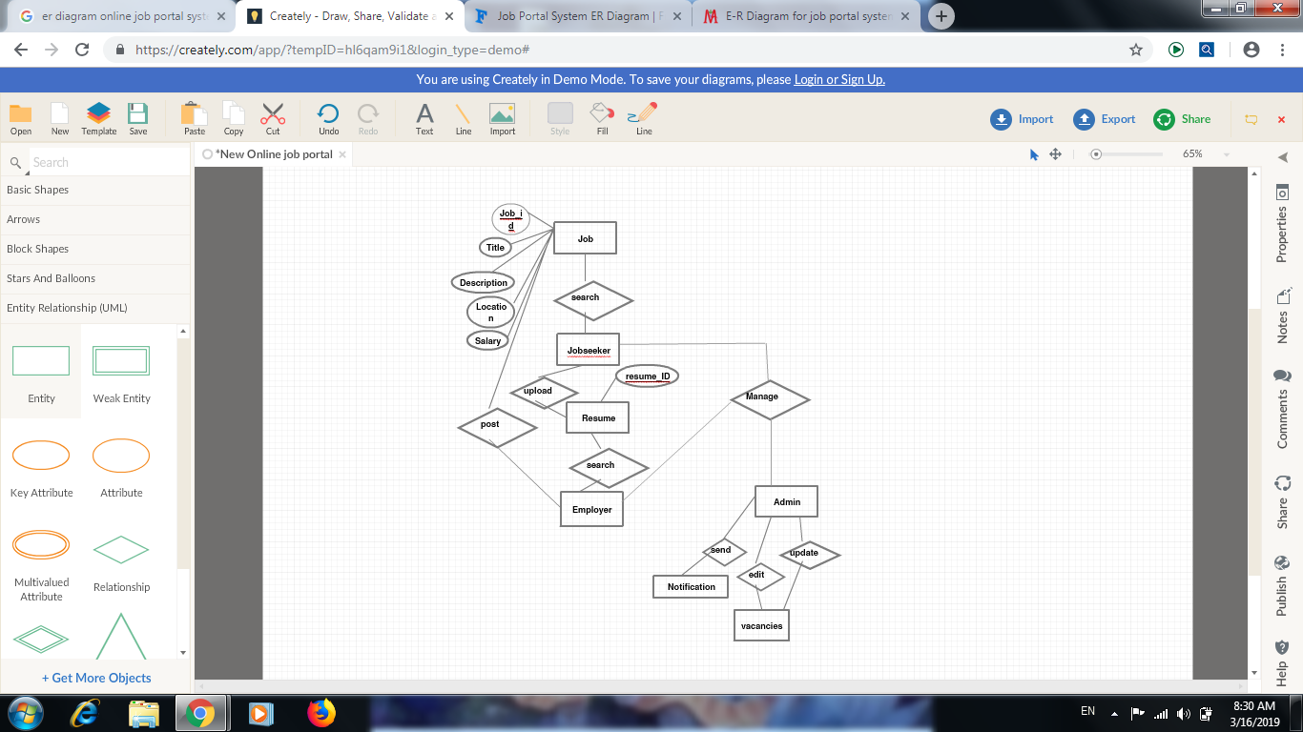

***Fig4.2.1.ER-Diagram***

1st Level DFD’s

**DFD For New Job Seeker Creation**

***Fig4.2.2.DFD1 Diagram***

Job Seeker Details

Registratio

Insert New Job Seeker

Verify Data

Check for Registration Details

Verify Data

Insert

Job Seeker

**4.3 UML Diagram**

In software engineering, a class diagram in the Unified Modelling Language (UML) is a type of static structure diagram that describes the structure of a system by showing the system's classes, their attributes, operations (or methods), and the relationships among objects.

**4.3.1 Use case Diagram**

 Use case diagrams are usually referred to as behavior diagrams used to describe a set of actions (use cases) that some system or systems (subject) should or can perform in collaboration with one or more external users of the system (actors).

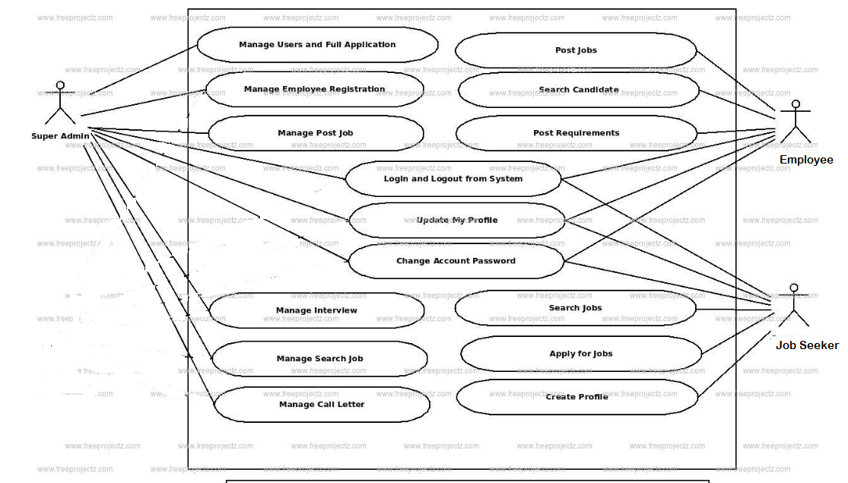

***Fig4.3.1. Use Case Diagram***

**4.3.2 Sequence Diagram**

A sequence diagram is an interaction diagram that shows how objects operate with one another and in what order. It is a construct of a message sequence chart. A sequence diagram shows object interactions arranged in time sequence.

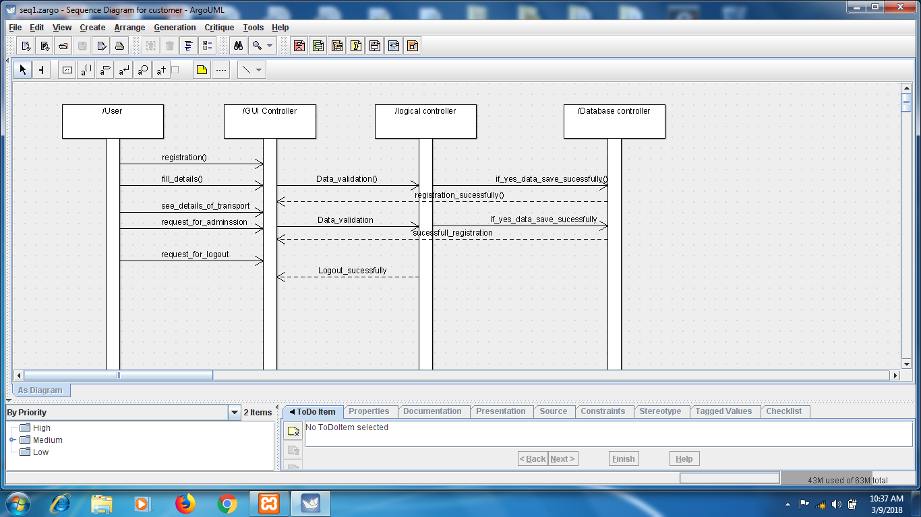

***Fig4.3.2.squence digram***

**4.3.4 Class Diagram**

A class diagram in the Unified Modeling Language (UML) is a type of static structure diagram that describes the structure of a system by showing the system's classes, their attributes, operations (or methods), and the relationships among objects.

The class diagram is the main building block of object-oriented modelling. It is used both for general conceptual modelling of the systematics of the application, and for detailed modelling translating the models into programming code. Class diagrams can also be used for data modelling. The classes in a class diagram represent both the main elements, interactions in the application, and the classes to be programmed.

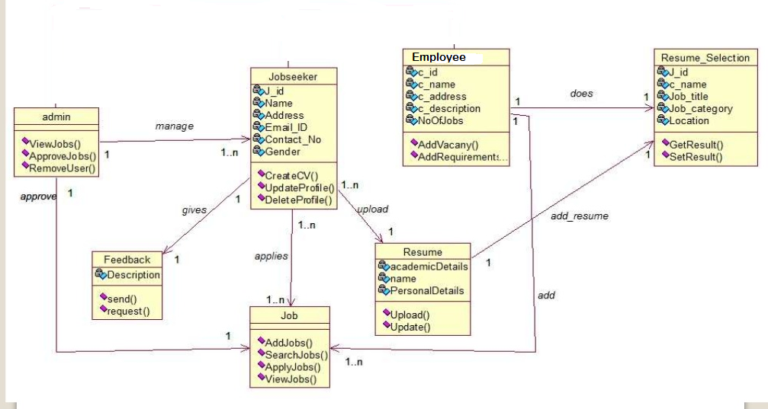

***Fig.4.3.3.1Class Diagram***

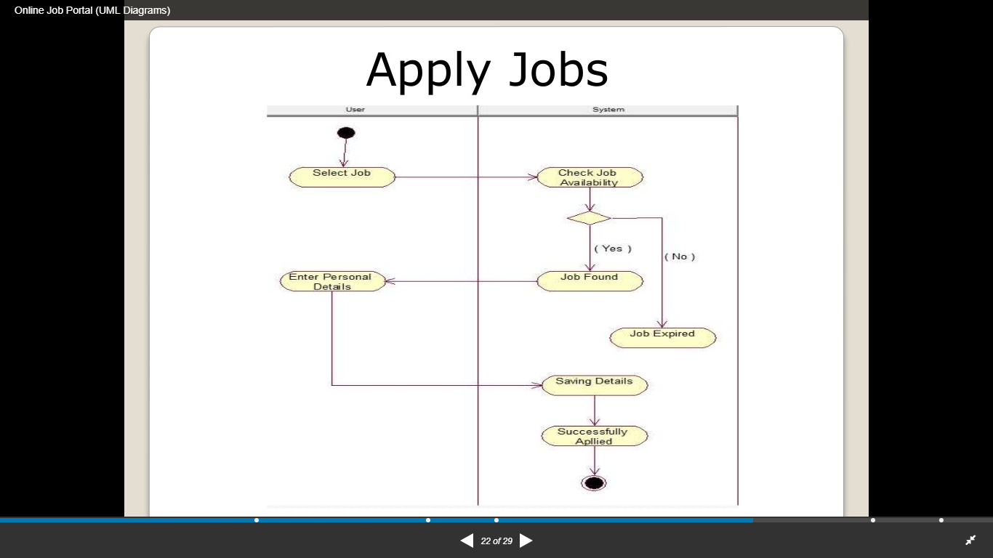

***f.g4.3.3.2Activity Diagram***

**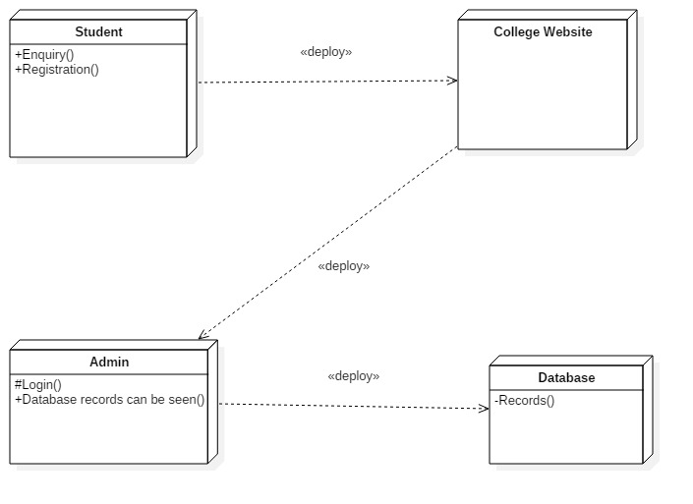*fig.4.3.4.3Deployment Diagram***

## CHAPTER -5

**IMPLEMENTATION DETAIL**

**5.1Coding**

**5.1.1 HTML Language**

Hyper Text Markup Language (HTML) is the standard [markup language](https://en.wikipedia.org/wiki/Markup_language) for creating [web pages](https://en.wikipedia.org/wiki/Web_page) and [web applications](https://en.wikipedia.org/wiki/Web_application). With [Cascading Style Sheets](https://en.wikipedia.org/wiki/Cascading_Style_Sheets) (CSS) and [JavaScript](https://en.wikipedia.org/wiki/JavaScript) it forms a triad of cornerstone technologies for the [World Wide Web](https://en.wikipedia.org/wiki/World_Wide_Web). [Web browsers](https://en.wikipedia.org/wiki/Web_browser) receive HTML documents from a [webserver](https://en.wikipedia.org/wiki/Webserver) or from local storage and render them into multimedia web pages. HTML describes the structure of a web page [semantically](https://en.wikipedia.org/wiki/Semantic) and originally included cues for the appearance of the document.

[HTML elements](https://en.wikipedia.org/wiki/HTML_element) are the building blocks of HTML pages. With HTML constructs, [images](https://en.wikipedia.org/wiki/Img_(HTML_element)) and other objects, such as [interactive forms,](https://en.wikipedia.org/wiki/Fieldset) may be embedded into the rendered page. It provides a means to create [structured documents](https://en.wikipedia.org/wiki/Structured_document) by denoting structural [semantics](https://en.wikipedia.org/wiki/Semantics) for text such as headings, paragraphs, lists, [links](https://en.wikipedia.org/wiki/Hyperlink), quotes and other items. HTML elements are delineated by tags, written using [angle brackets](https://en.wikipedia.org/wiki/Bracket#Angle_brackets). Tags such as <img /> and <input /> introduce content into the page directly. Others such as <p>...</p> surround and provide information about document text and may include other tags as sub-elements. Browsers do not display the HTML tags, but use them to interpret the content of the page.

HTML can embed programs written in a [scripting language](https://en.wikipedia.org/wiki/Scripting_language) such as [JavaScript](https://en.wikipedia.org/wiki/JavaScript) which affect the behaviour and content of web pages. Inclusion of CSS defines the look and layout of content. The [World Wide Web Consortium](https://en.wikipedia.org/wiki/World_Wide_Web_Consortium) (W3C), maintainer of both the HTML and the CSS standards, has encouraged the use of CSS over explicit presentational HTML since 1997.

<html>

<div id="wowslider-container0">

<div class="ws_images"><ul>

<li><img src="data0/images/21.jpg" alt="Computer Lab" title="Computer Lab" id="wows0_0"/></li>

<li><img src="data0/images/31.jpg" alt="Computer Lab" title="Computer Lab" id="wows0_1"/></li>

<li><img src="data0/images/college.jpg" alt="Students" title="college" id="wows0_2"/></li>

<li><a href="http://wowslider.com"><img src="data0/images/dsc_2569.jpg" alt="responsive slider" title="Teaching Learning Process" id="wows0_3"/></a></li>

<li><img src="data0/images/dsc_2571.jpg" alt="DSC_2571" title="DSC_2571" id="wows0_4"/></li>

</ul></div>

<div class="ws_bullets"><div>

<a href="#" title="Computer Lab"><span><img src="data0/tooltips/21.jpg" alt="Computer Lab"/>1</span></a>

<a href="#" title="Computer Lab"><span><img src="data0/tooltips/31.jpg" alt="Computer Lab"/>2</span></a>

<a href="#" title="Students"><span><img src="data0/tooltips/college.jpg" alt="Students"/>3</span></a>

<a href="#" title="Teaching Learning Process"><span><img src="data0/tooltips/dsc_2569.jpg" alt="Teaching Learning Process"/>4</span></a>

<ahref="#"title="DSC_2571"><span><img src="data0/tooltips/dsc_2571.jpg" alt="DSC_2571"/>5</span></a>

</div></div>

</html>

**5.1.2 Cascading Style Sheet (CSS) Language**

Cascading Style Sheets (CSS) is a [style sheet language](https://en.wikipedia.org/wiki/Style_sheet_language) used for describing the [presentation](https://en.wikipedia.org/wiki/Presentation_semantics) of a document written in a [markup language](https://en.wikipedia.org/wiki/Markup_language). Although most often used to set the visual style of [web pages](https://en.wikipedia.org/wiki/Web_page) and user interfaces written in [HTML](https://en.wikipedia.org/wiki/HTML) and [XHTML](https://en.wikipedia.org/wiki/XHTML), the language can be applied to any [XML](https://en.wikipedia.org/wiki/XML) document, including [plain XML](https://en.wikipedia.org/wiki/Plain_Old_XML), [SVG](https://en.wikipedia.org/wiki/Scalable_Vector_Graphics) and [XUL](https://en.wikipedia.org/wiki/XUL), and is applicable to rendering in [speech](https://en.wikipedia.org/wiki/Speech_synthesis), or on other media. Along with HTML and [JavaScript](https://en.wikipedia.org/wiki/JavaScript), CSS is a cornerstone technology used by most websites to create visually engaging webpages, user interfaces for [web applications](https://en.wikipedia.org/wiki/Web_applications), and user interfaces for many mobile applications.

CSS is designed primarily to enable [the separation of document content from document presentation](https://en.wikipedia.org/wiki/Separation_of_presentation_and_content), including aspects such as the [layout](https://en.wikipedia.org/wiki/Page_layout), [colors](https://en.wikipedia.org/wiki/Color), and [fonts](https://en.wikipedia.org/wiki/Typeface). This separation can improve content [accessibility](https://en.wikipedia.org/wiki/Accessibility), provide more flexibility and control in the specification of presentation characteristics, enable multiple HTML pages to share formatting by specifying the relevant CSS in a separate .css file, and reduce complexity and repetition in the structural content.

Separation of formatting and content makes it possible to present the same markup page in different styles for different rendering methods, such as on-screen, in print, by voice (via speech-based browser or [screen reader](https://en.wikipedia.org/wiki/Screen_reader)), and on [Braille-based](https://en.wikipedia.org/wiki/Braille_display) tactile devices. It can also display the web page differently depending on the screen size or viewing device. Readers can also specify a different style sheet, such as a CSS file stored on their own computer, to override the one the author specified. Changes to the [graphic design](https://en.wikipedia.org/wiki/Graphic_design) of a document (or hundreds of documents) can be applied quickly and easily, by editing a few lines in the CSS file they use, rather than by changing markup in the documents.

The CSS specification describes a priority scheme to determine which style rules apply if more than one rule matches against a particular element. In this so-called cascade, priorities (or weights) are calculated and assigned to rules, so that the results are predictable.

The CSS specifications are maintained by the [World Wide Web Consortium](https://en.wikipedia.org/wiki/World_Wide_Web_Consortium) (W3C). Internet media type ([MIME type](https://en.wikipedia.org/wiki/MIME_media_type)) text/css is registered for use with CSS by [RFC 2318](https://tools.ietf.org/html/rfc2318) (March 1998). The W3C operates a free [CSS validation service](https://en.wikipedia.org/wiki/W3C_Markup_Validation_Service#CSS_validation) for CSS documents.

For eg. <html>

<head>

<style>

{ width:200px;

background:#FFF;

position:absolute;

bottom:40px;

padding:10px 20px;

text-indent: 0px;

moz-border-radius: 0px;

-webkit-border-radius: 0px;

border-radius: 0px;

z-index:1000;

-ms-filter:"progid: DXImageTransform.Microsoft.Alpha(Opacity=100)";

filter: alpha(opacity=1);

opacity: 1;

}

<body>

**5.1.3JavaScript Language**

JavaScript is a [high-level](https://en.wikipedia.org/wiki/High-level_programming_language), [dynamic](https://en.wikipedia.org/wiki/Dynamic_programming_language), and [interpreted](https://en.wikipedia.org/wiki/Interpreted_language) [programming language](https://en.wikipedia.org/wiki/Programming_language). It has been standardized in the [ECMA Script](https://en.wikipedia.org/wiki/ECMAScript) language specification. Alongside [HTML](https://en.wikipedia.org/wiki/HTML) and [CSS](https://en.wikipedia.org/wiki/CSS), JavaScript is one of the three core technologies of [World Wide Web](https://en.wikipedia.org/wiki/World_Wide_Web) [content production](https://en.wikipedia.org/wiki/Content_engineering); the majority of [websites](https://en.wikipedia.org/wiki/Website) employ it, and all modern [Web browsers](https://en.wikipedia.org/wiki/Web_browser) support it without the need for [plug-ins](https://en.wikipedia.org/wiki/Browser_extension). JavaScript is [prototype-based](https://en.wikipedia.org/wiki/Prototype-based_programming) with [first-class functions](https://en.wikipedia.org/wiki/First-class_function), making it a [multi-paradigm](https://en.wikipedia.org/wiki/Multi-paradigm) language, and [functional](https://en.wikipedia.org/wiki/Functional_programming) [programming styles](https://en.wikipedia.org/wiki/Programming_paradigm). It has an [API](https://en.wikipedia.org/wiki/Application_programming_interface) for working with text, [arrays](https://en.wikipedia.org/wiki/Array_data_type), dates and [regular expressions](https://en.wikipedia.org/wiki/Regular_expression), but does not include any [I/O](https://en.wikipedia.org/wiki/Input/output), such as networking, storage, or graphics facilities, relying for these upon the host environment in which it is embedded.

Although there are strong outward similarities between JavaScript and Java, including language name, [syntax](https://en.wikipedia.org/wiki/Syntax_(programming_languages)), and respective [standard libraries](https://en.wikipedia.org/wiki/Standard_library), the two are distinct languages and differ greatly in their design. JavaScript was influenced by programming languages such as [Self](https://en.wikipedia.org/wiki/Self_(programming_language)) and [Scheme](https://en.wikipedia.org/wiki/Scheme_(programming_language)).

JavaScript is also used in environments that are not Web-based, such as [PDF](https://en.wikipedia.org/wiki/Portable_Document_Format) documents, [site-specific browsers](https://en.wikipedia.org/wiki/Site-specific_browser), and [desktop widgets](https://en.wikipedia.org/wiki/Desktop_widget). Newer and faster JavaScript [virtual machines](https://en.wikipedia.org/wiki/Virtual_machine) (VMs) and platforms built upon them have also increased the popularity of JavaScript for [server-side](https://en.wikipedia.org/wiki/Server-side) [Web applications](https://en.wikipedia.org/wiki/Web_application). On the [client side](https://en.wikipedia.org/wiki/Client_side), developers have traditionally implemented JavaScript as an [interpreted](https://en.wikipedia.org/wiki/Interpreter_(computing)) language, but more recent browsers perform [just-in-time compilation](https://en.wikipedia.org/wiki/Just-in-time_compilation). Programmers also use JavaScript in [video-game development](https://en.wikipedia.org/wiki/Video_game_development), in crafting desktop and mobile applications, and in server-side [network programming](https://en.wikipedia.org/wiki/Computer_network_programming) with run-time environments such as [Node.js](https://en.wikipedia.org/wiki/Node.js).

<html>

<body>

For eg

<h1>My First JavaScript</h1>

<button type="button"

onclick="document.getElementById('demo').innerHTML = Date()">

Click me to display Date and Time.</button>

<p id="demo"></p>

</body>

</html>

**5.1.4 PHP Language**

PHP is a [server-side scripting](https://en.wikipedia.org/wiki/Server-side_scripting) language designed primarily for [web development](https://en.wikipedia.org/wiki/Web_development) but also used as a [general-purpose programming language](https://en.wikipedia.org/wiki/General-purpose_programming_language). Originally created by [Rasmus Lerdorf](https://en.wikipedia.org/wiki/Rasmus_Lerdorf) in 1994, the PHP [reference implementation](https://en.wikipedia.org/wiki/Reference_implementation) is now produced by The PHP Development Team. PHP originally stood for PersonalHomePage,  but it now stands for the [recursive acronym](https://en.wikipedia.org/wiki/Recursive_acronym) PHP*:* HypertextPre-processor.

PHP code may be embedded into [HTML](https://en.wikipedia.org/wiki/HTML) or HTML5 code, or it can be used in combination with various [web template systems](https://en.wikipedia.org/wiki/Web_template_system), [web content management systems](https://en.wikipedia.org/wiki/Web_content_management_system) and [web frameworks](https://en.wikipedia.org/wiki/Web_framework). PHP code is usually processed by a PHP [interpreter](https://en.wikipedia.org/wiki/Interpreter_(computing)) implemented as a [module](https://en.wikipedia.org/wiki/Plugin_(computing)) in the web server or as a [Common Gateway Interface](https://en.wikipedia.org/wiki/Common_Gateway_Interface) (CGI) executable. The web server combines the results of the interpreted and executed PHP code, which may be any type of data, including images, with the generated web page. PHP code may also be executed with a [command-line interface](https://en.wikipedia.org/wiki/Command-line_interface) (CLI) and can be used to implement [standalone](https://en.wikipedia.org/wiki/Computer_software) [graphical applications](https://en.wikipedia.org/wiki/Graphical_user_interface).

The standard PHP interpreter, powered by the [Zend Engine](https://en.wikipedia.org/wiki/Zend_Engine), is [free software](https://en.wikipedia.org/wiki/Free_software) released under the [PHP License](https://en.wikipedia.org/wiki/PHP_License). PHP has been widely ported and can be deployed on most web servers on almost every [operating system](https://en.wikipedia.org/wiki/Operating_system) and [platform](https://en.wikipedia.org/wiki/Computing_platform), free of charge.

The PHP language evolved without a written [formal specification](https://en.wikipedia.org/wiki/Formal_specification) or standard until 2014, leaving the canonical PHP interpreter as a [de facto](https://en.wikipedia.org/wiki/De_facto) standard. Since 2014 work has gone on to create a formal PHP specification.

for eg.

<?php

if(isset($_POST['submit1']))

{

$rollno=$_POST['rollno'];

$uname=$_POST['uname'];

$pass=$_POST['pass'];

$mobileno=$_POST['mobileno'];

$email=$_POST['email'];

mysql_connect("localhost","root","")or die ("error in connectnnio");

mysql_select_db("proj") or die ("error in db selection");

$query1="insert into register(roll_no,name,pass,mobile,email) value ('$rollno','$uname','$pass','$mobileno','$email')";

if(mysql_query($query1))

{

echo "<script>alert('Registered Successfully')</script>";

}

else

{

echo "<script>alert('Error')</script>";

}

}

?>

**5.1.5 MYSQL**

SQL  Structured Query Languageis a domain-specific language used in programming and designed for managing data held in a relational database management system (RDBMS), or for stream processing in a relational data stream management system (RDSMS). Originally based upon relational algebra and tuple relational calculus, SQL consists of a data definition language, data manipulation language, and data control language. The scope of SQL includes data insert, query, update and delete, schema creation and modification, and data access control.

SQL was one of the first commercial languages for Edgar F. Codd's relational model, as described in his influential 1970 paper, "A Relational Model of Data for Large Shared Data Banks." Despite not entirely adhering to the relational model as described by Codd, it became the most widely used database language.

SQL became a standard of the American National Standards Institute (ANSI) in 1986, and of the International Organization for Standardization (ISO) in 1987.Since then, the standard has been revised to include a larger set of features. Despite the existence of such standards, most SQL code is not completely portable among different database systems without adjustments.

For eg.

$query1="insert into register(roll_no,name,pass,mobile,email) value ('$rollno','$uname','$pass','$mobileno','$email')";

5.2 **Testing Principles:**

Software testability is simply how easily computers programs can be tested. The checklist that follows provides a set of characteristics that lead to testable software.

* Portability.
* Observable.
* Controllability.
* Decomposability.
* Simplicity.
* Stability.
* Understandability.

1. All tests should be traceable to customer requirement.

2. Test should be planned Long before Testing Begins

3. The pare to principle applies to software testing. The pare to principles states that 80% of all errors uncover during testing will likely be traceable to 20% of all program component.

4. Testing should begin “In the small” and progress towards testing “In the Large”.

5. Exhaustive Testing is not possible.

6. To be most effective, testing should be conducted by independent third party.

**5.2.1 Testing Terminology:-**

1. **Testability:**

Software Testability can be defined as “How easily a computer program can be tested.” The following characteristics lead to testable software.

1. **Operability:**

This is an ability to get easily operate. ”the better it works, the more efficiently it can tested. ” if a system is designed and implemented with quality in mind, relatively few bugs will block the execution of tests, allowing testing to progress without fits and starts.

1. **Observability:**

“What you see is what you test.” Inputs provided as part of test during execution. Incorrect output is easily identified. Internal errors are automatically detected and reported. Source code is accessible.

1. **Controllability:**

“The better we can control the software, the more the testing can be automated and optimized.” Software and hardware states and variables can be controlled directed by the engineer. Tests can be conveniently specified, automated, and reproduced.

1. **Simplicity:**

“The less there is to test, the more quickly we can test it.” The program should execute functional simplicity, structural simplicity and code simplicity

**6.Stability:**

“The fewer the changes, the fewer disruptions to testing.” Changes to the software are infrequent, controlled when they do occur, and do not invalidate existing tests. The software recovers well from failures.

**7.Understandability:**

“The more information we have, the smarter we will test.” The architectural design and the dependences between internal, external and shared components are well understood. Technical documentation is instantly accessible, well organized, specific, and detailed, and accurate. Changes to the design are communication to testers.

**5.2.3Testing method:**

The phase of system development life cycle tests system design. Testing of system decides whether the newly designed system works properly or not. After the development of documentation manually about the system this stage is checked. And if the system working properly then it will be considered for implementation and if isn’t then system analyst is informed to find out generated errors or problems and to find out its solutions. This process is known as debugging.

For any software system testing means to check out it’s coding. If there is not any problem in the coding then that code is proper and efficient to design. If we are not getting proper or required output then we have to debug the system coding. So, the debugging is also a subpart of the testing section. If the system runs correctly during testing then is no need to debug.

**1.Black Box Testing:-**

This is concerned with the proper execution of the program specification. In this testing, each function or sub program used in the main is first identified. It is complementary to White Box Testing. It uncovers a different class of errors which are not discovered by White box Methods

**2.White Box Testing:-**

This is concerned with implementation of the program. In this, different programming structures and data structures used in program are tested for missing function, performance errors, Errors in external database access, Initializing and terminating errors.

**3.Alpha Testing:-**

Test performed at the developer’s site Before the system is finally installed in the working environment is known as alpha Testing. It is also known as Acceptance test since it is performed before the system is accepted as being fit for intended users.

**4.Beta Testing:-**

In this testing, the system is delivered to a number of potential uses who agree out use that system and provide feedback to the desiners . Testing should be repeated if any modification is done based on the feedback given by the users. Hence, it is sometimes called as regression testing.

5.**System Testing:-**

They performed a series of different tests with the intend to fully exercise our system. Although each test had a different purpose, all worked to verify that system elements are working properly, integrated and perform allocated functions.

**5.2.3 Feature to be tested:**

Testing will consist of a several phase (see introduction), each phase may or may not include testing of anyone or more of the following product:

1. Testing the interaction between the application

2. To test the ability of the project to compile programs written in Vb.net environments

**5.2.4 Objective of Testing:**

Software Testing is Critical element of software quality assurance and represent the ultimate review of specification, design and code generation.

In any software development numbers of steps are involved. During execution of these steps these are possibilities of error occurrence. So once the coding is started the code must be tested throughout the coding process and at final stage when the coding is completed to uncover as many errors as possible before delivery to the customer. Here our goals is to design a series of tests cases that a high likelihood of finding error.

**5.Characteristic of Testing Strategies:**

Following are the features or characteristics of testing strategy. A successful testing strategy need to have the following characteristics to produce the expected results.

1. Testing strategy should specify product requirements in a quantifiable or in measurable manner long before testing begins.
2. Testing objectives should be explicitly mentioned in the testing strategy.
3. A good testing strategy understands the users of the software and develops a profile for each user category.
4. One of the important characteristics of testing strategy is that it should develop a testing plan that focuses on “rapid cycle testing”.
5. Test strategy should build “robust” software i.e.Designed to test itself.
6. Formal technical reviews needs to be conducted to assess the test strategy and test cases themselves to ensure the expected results.
7. Testing strategy should develop a continuous improvement approach for the test the expected results.

5.4**SCREEN-SHOTS:**

**Home page**

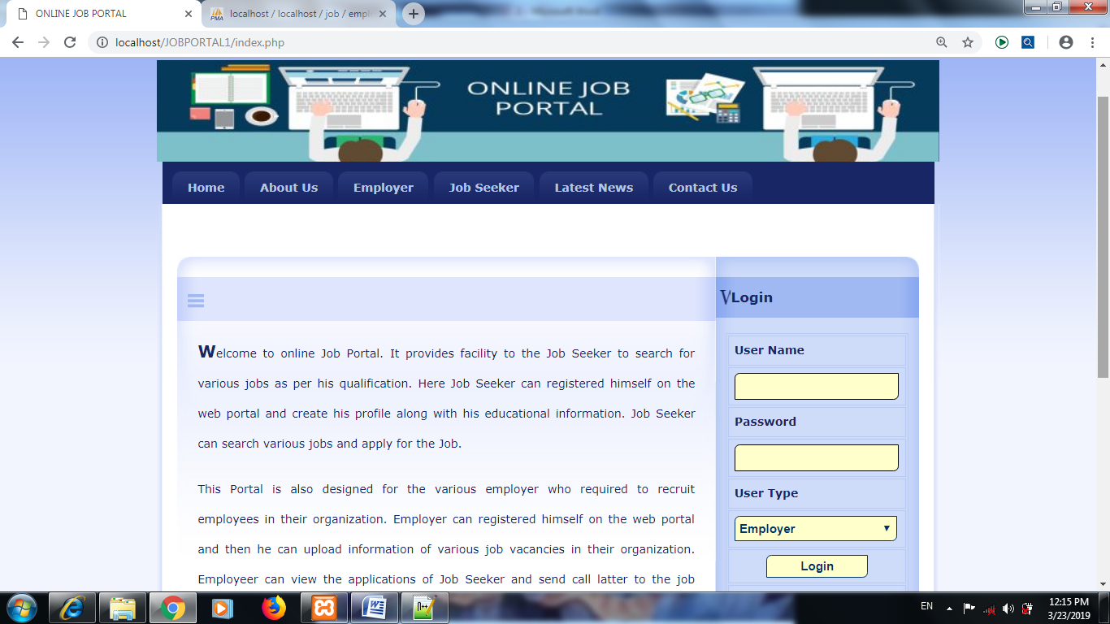

**About us**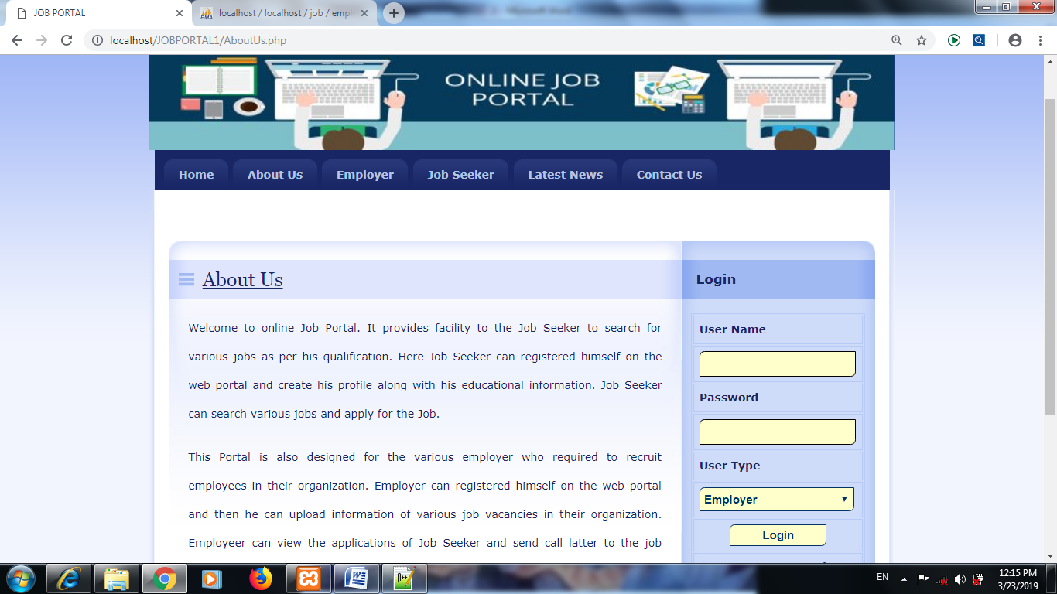

**Employer**

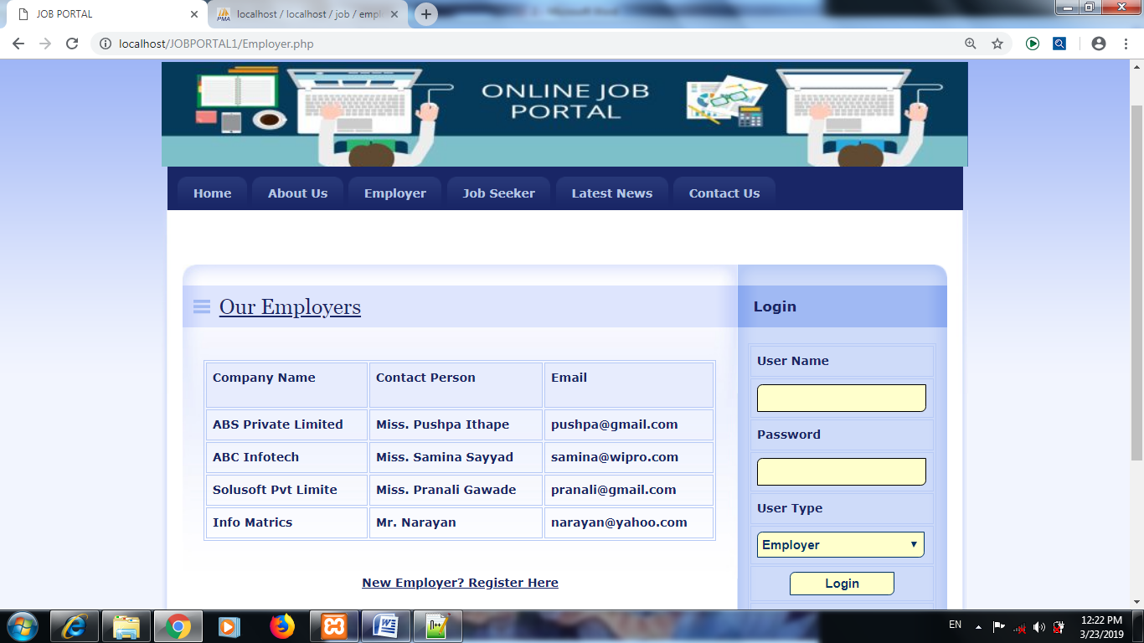

**Job Seeker**

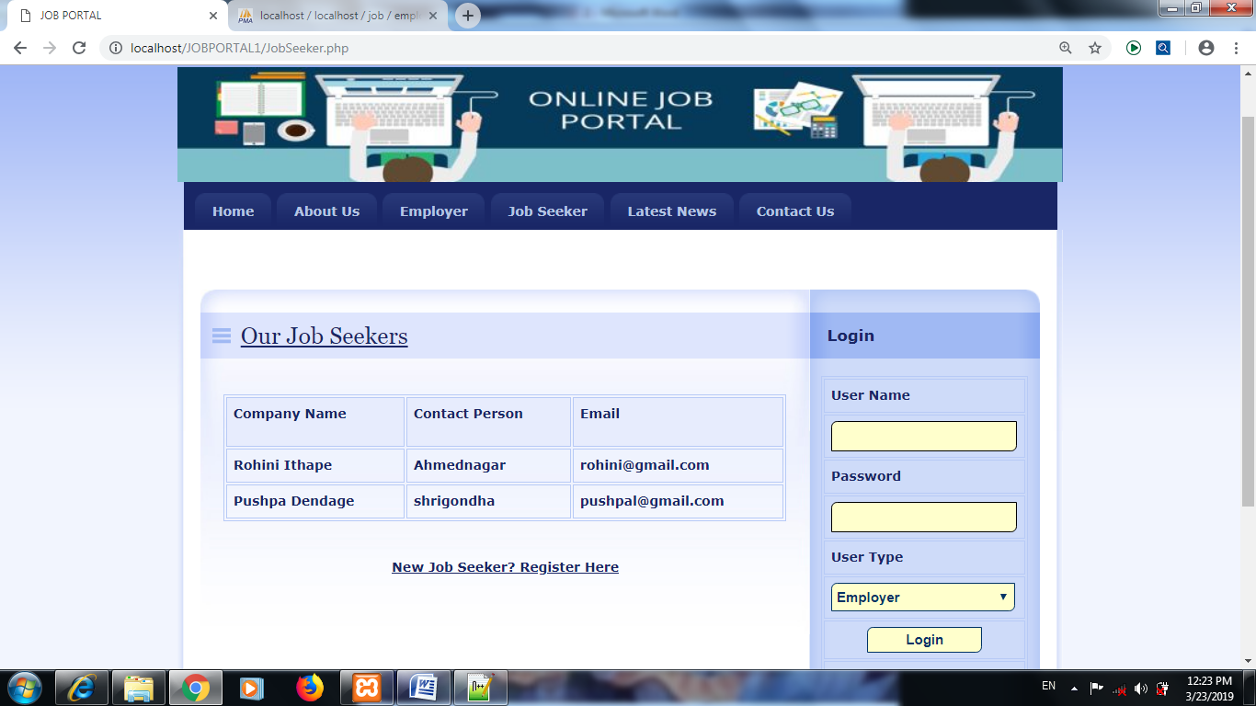

**Latest News**

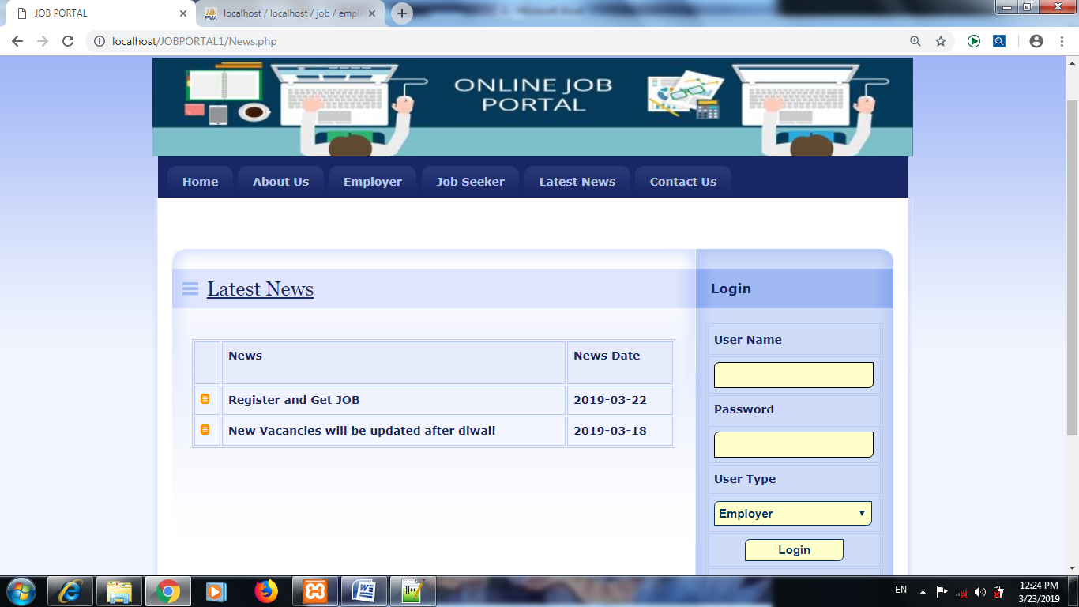

**Contact Us**

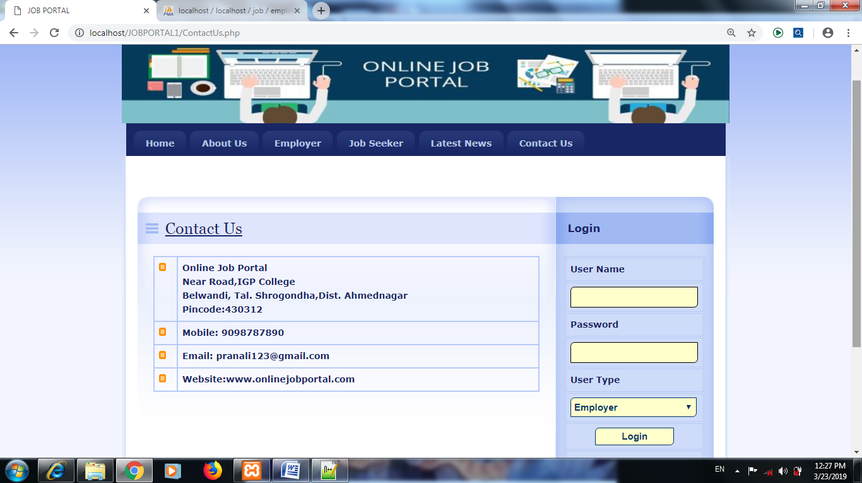

**Administrator Login**

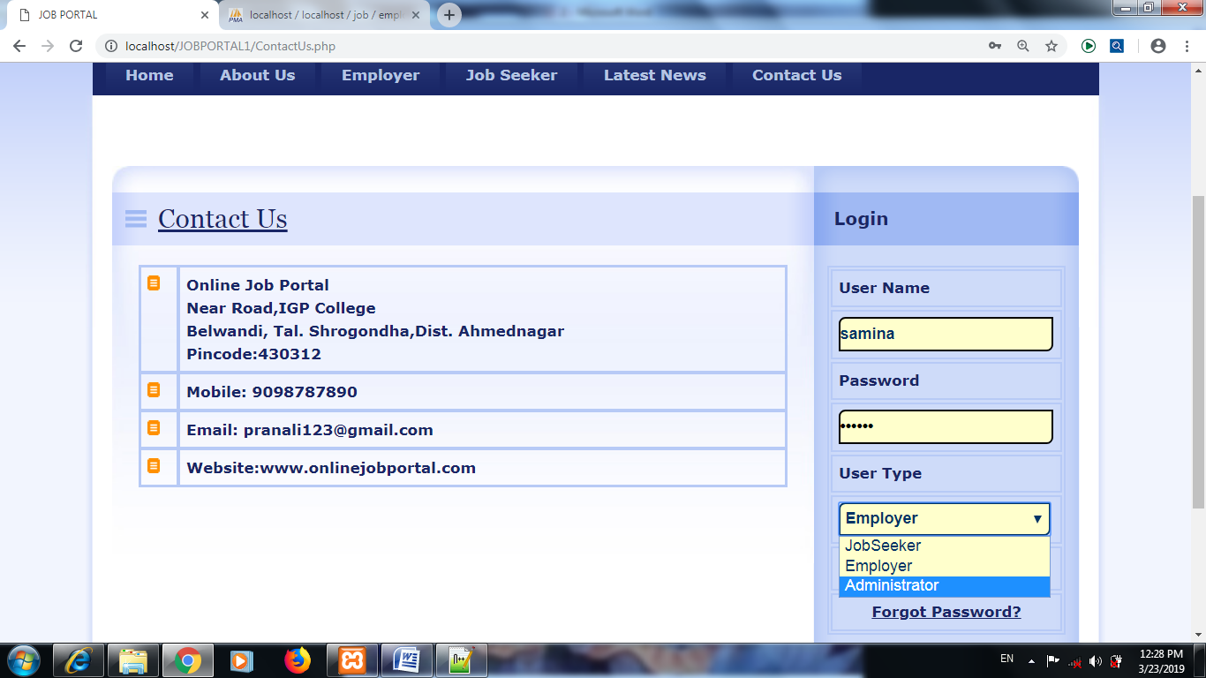

**Admin Create new user**

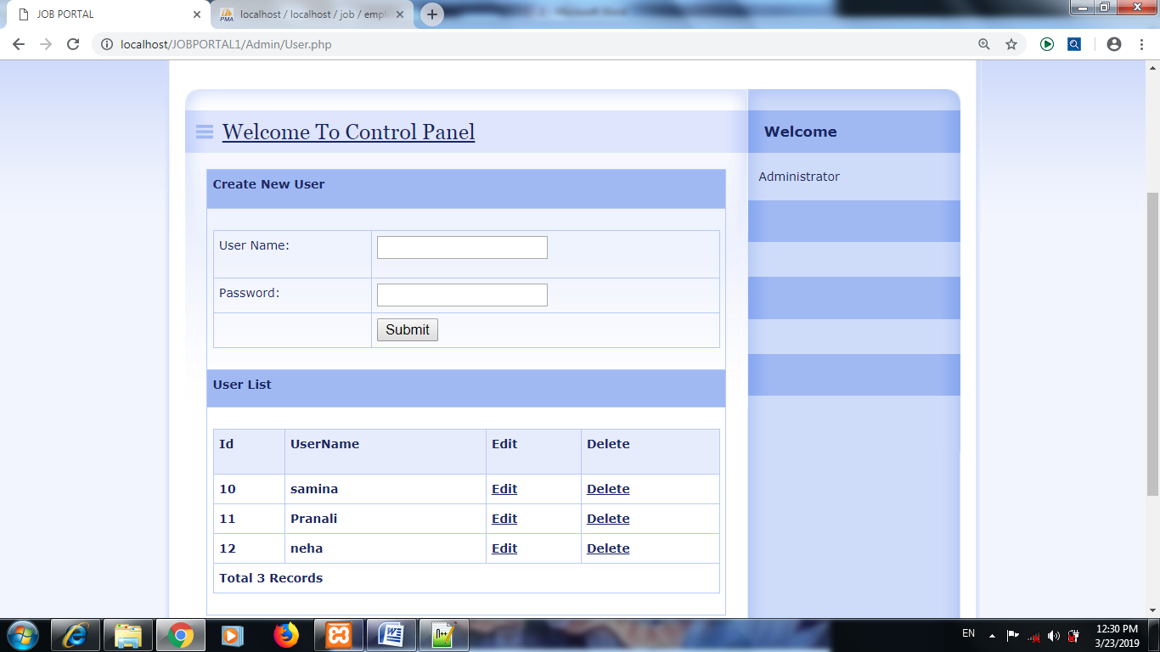

**Admin Manage Job Seeker**

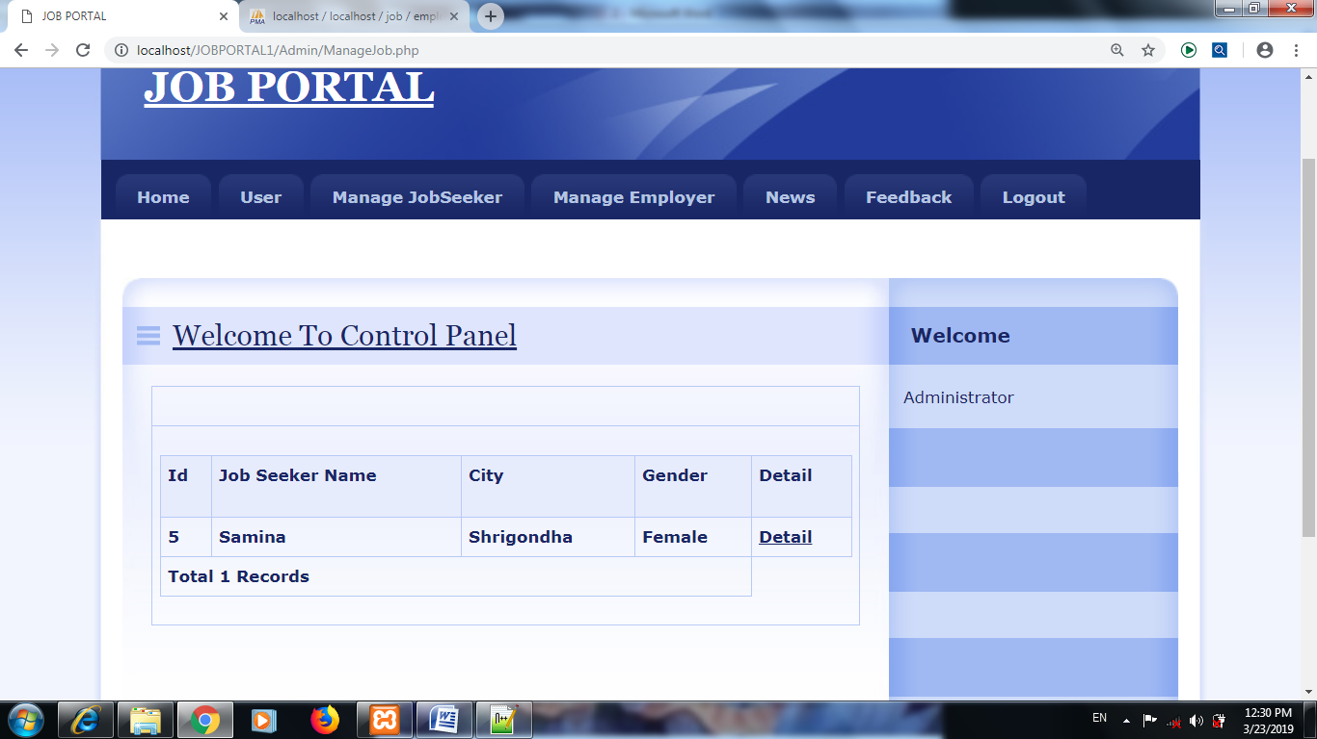

**Admin Manage Employer**

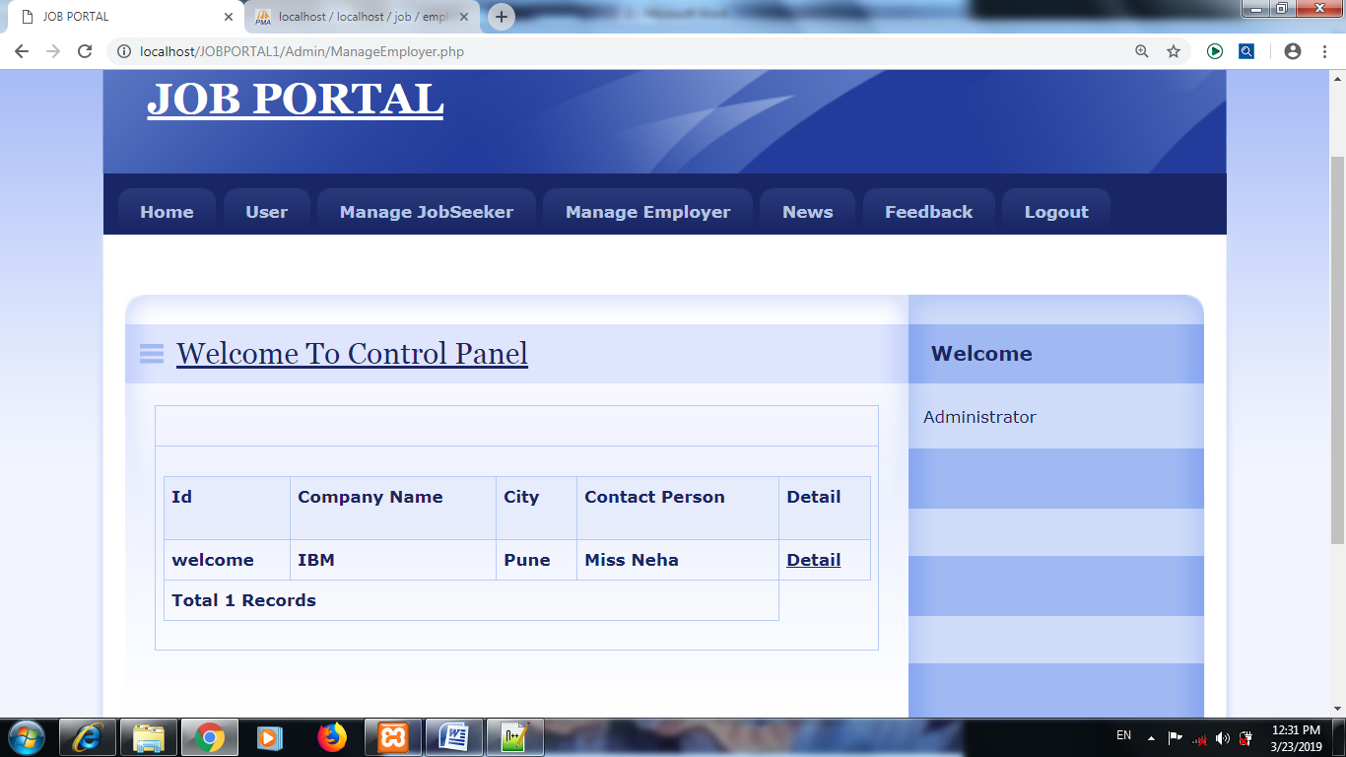

**Admin Manage News**

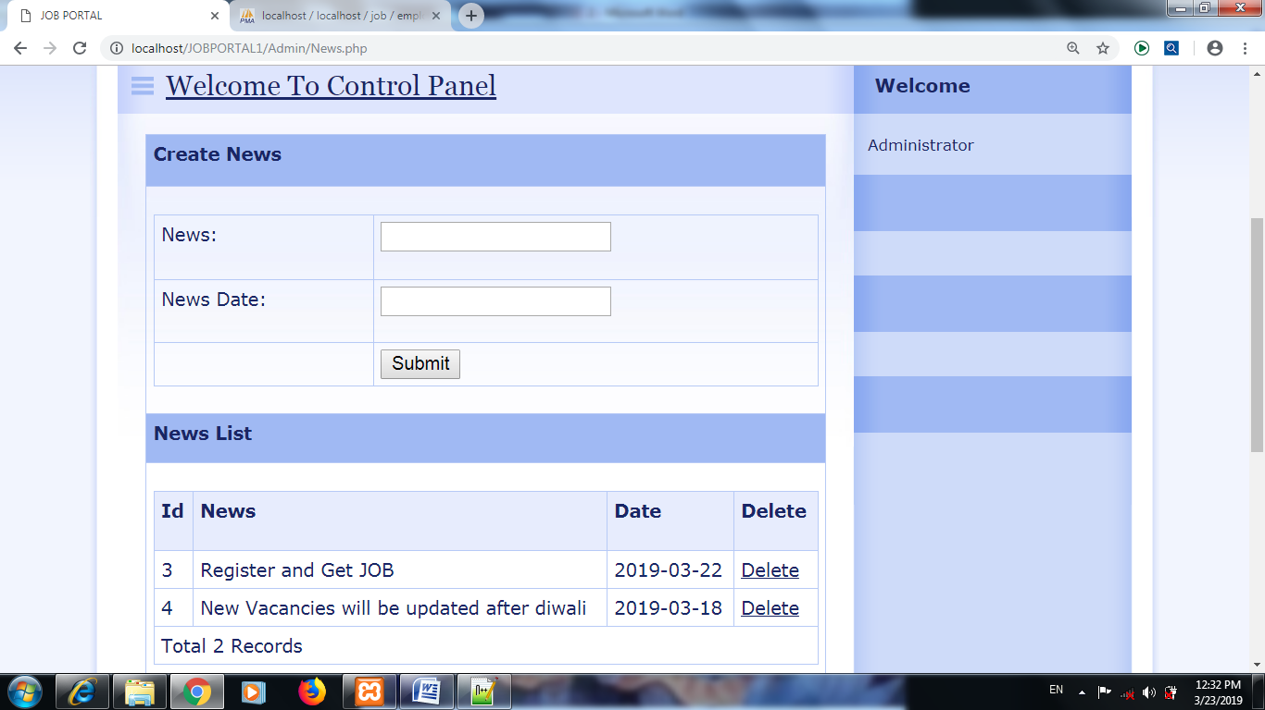

**Employer Login**

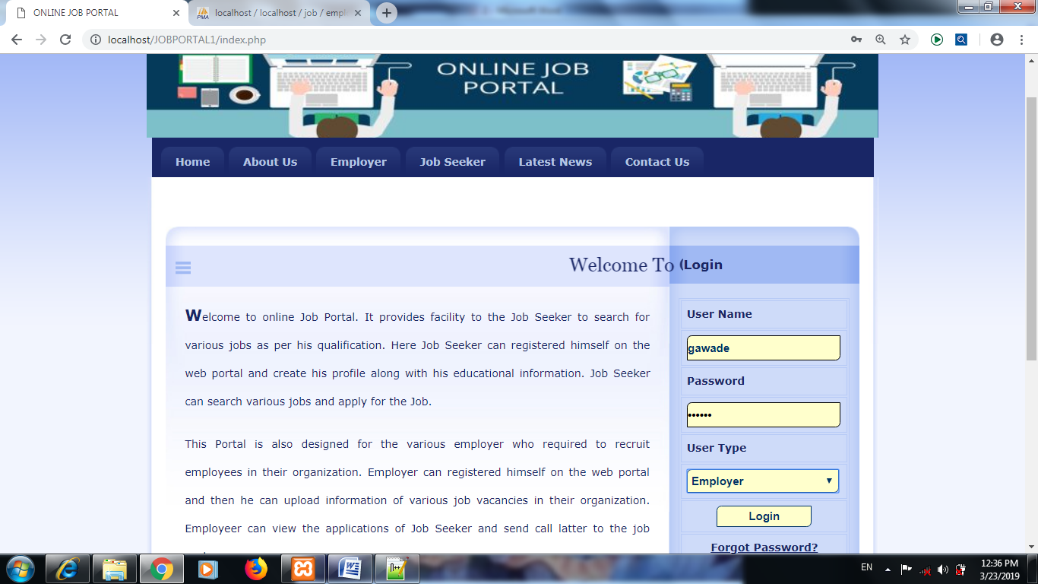

**Employer Home Screen**

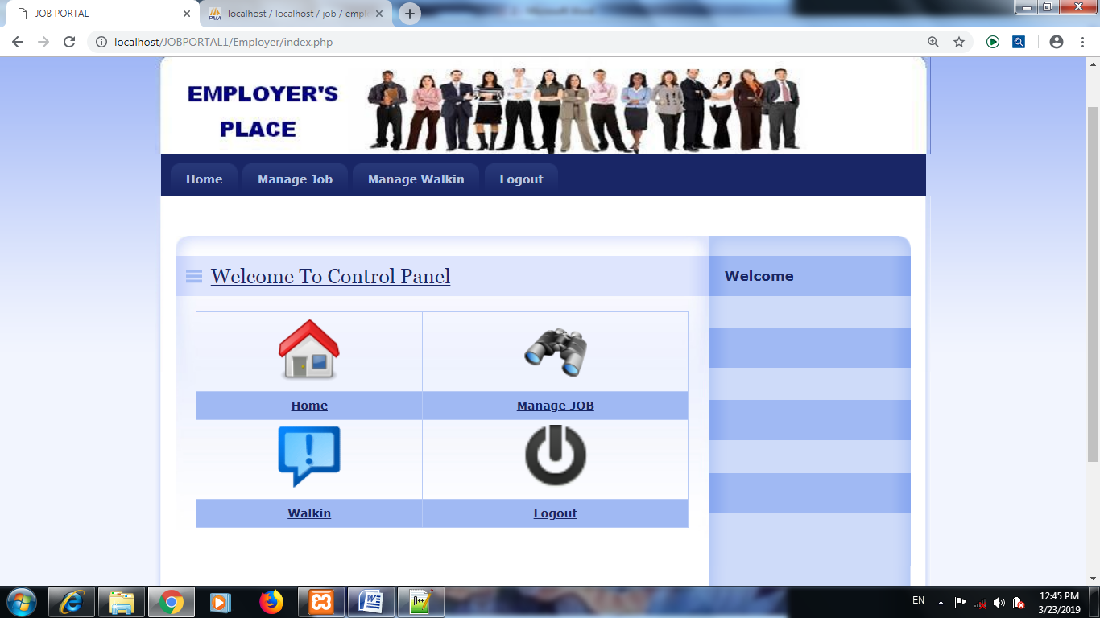

**Employer Manage Job**

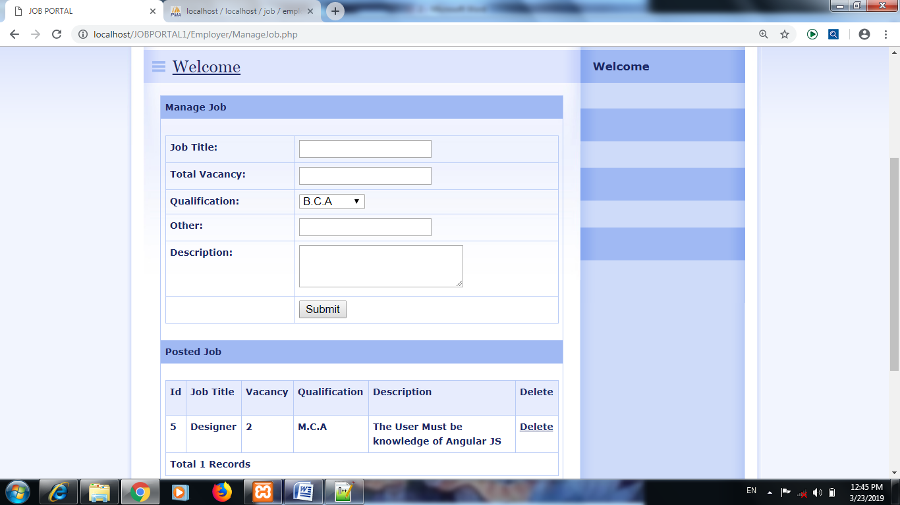

**Employer manage Walk IN**

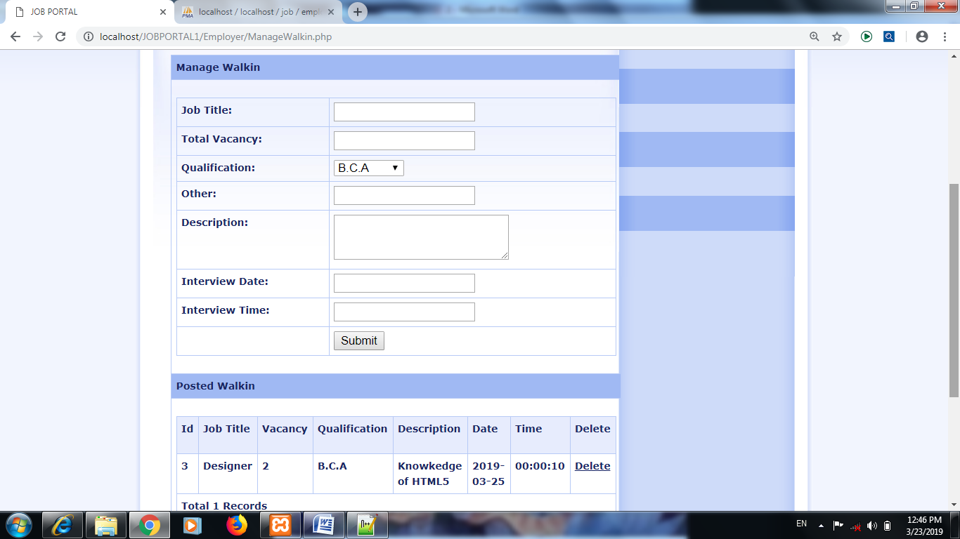

**Job seeker Login**

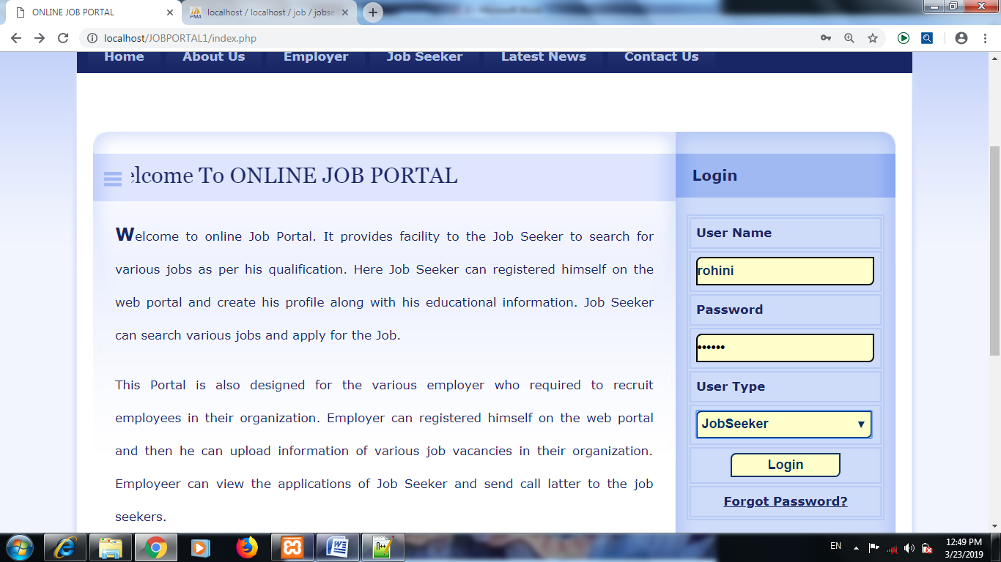

**Job Seeker Home page**

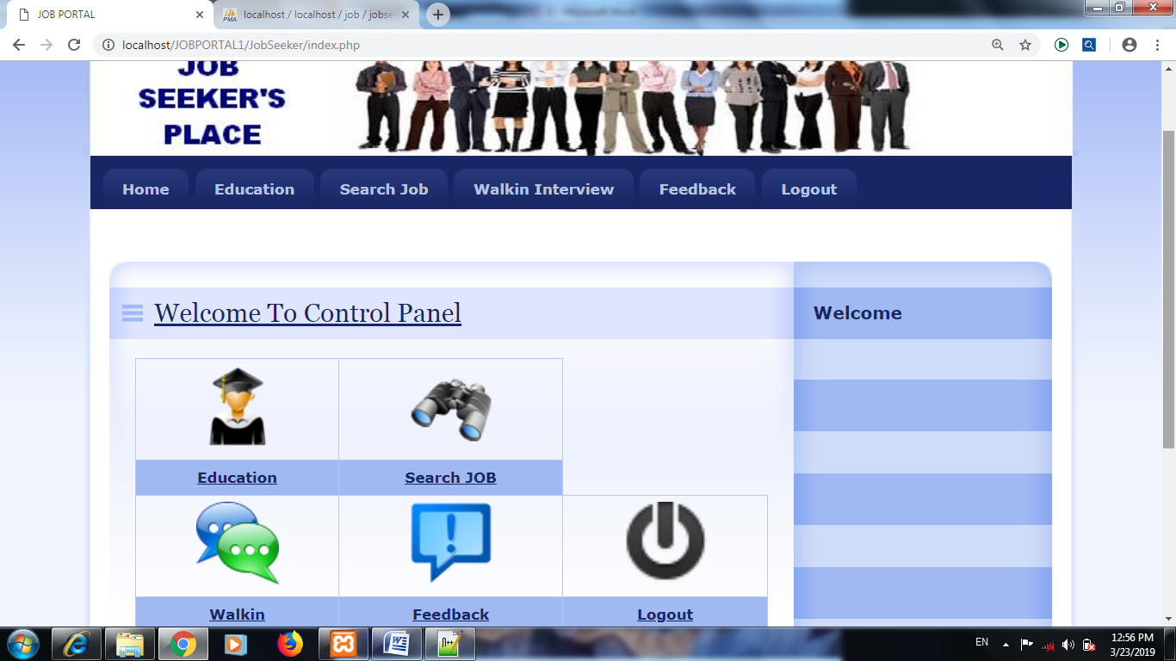

**Search Job**

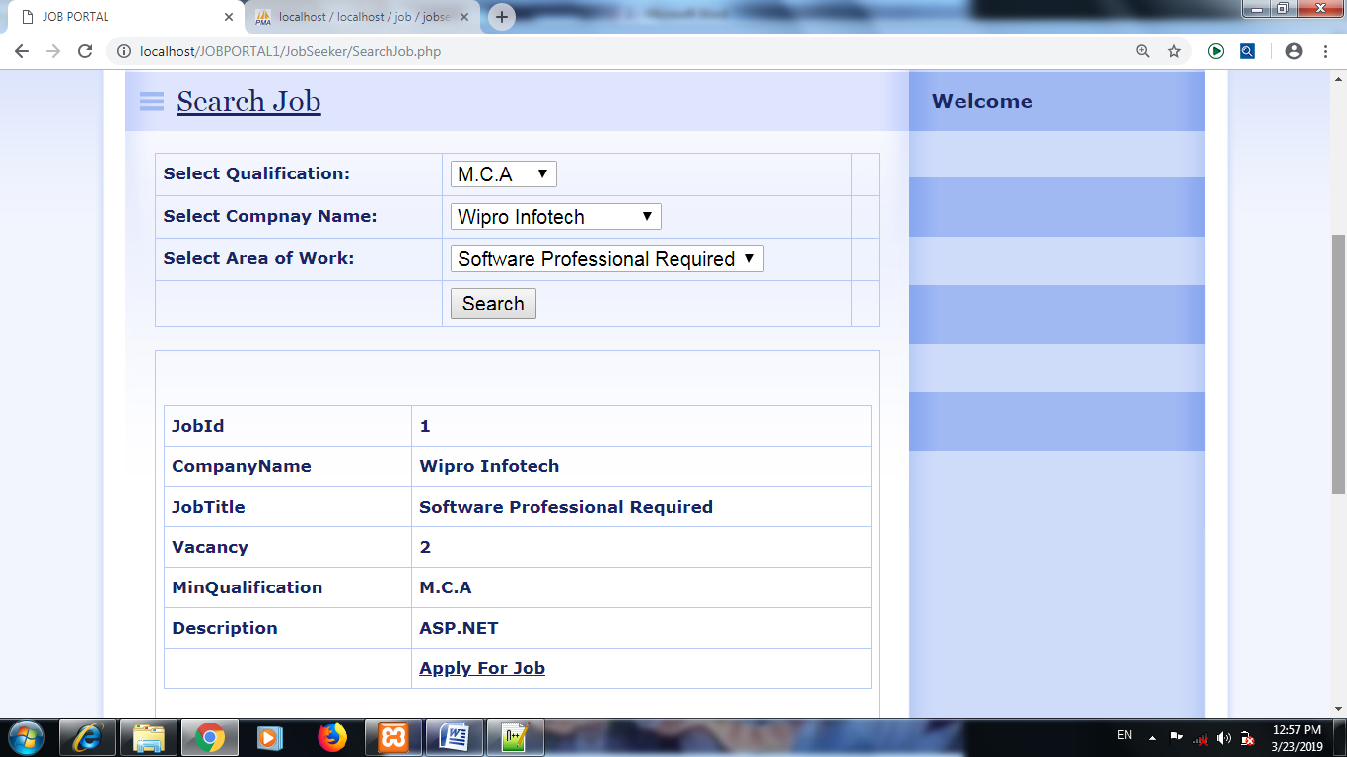

**Walk in Interview Details**

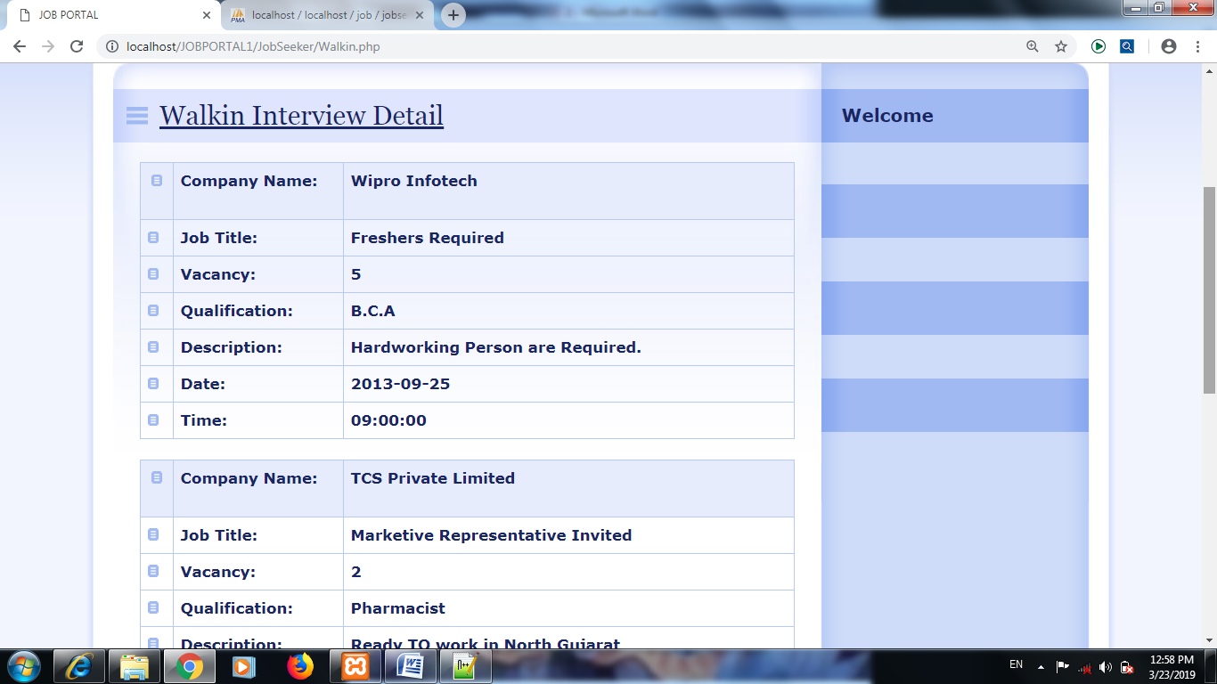

**Feedback**

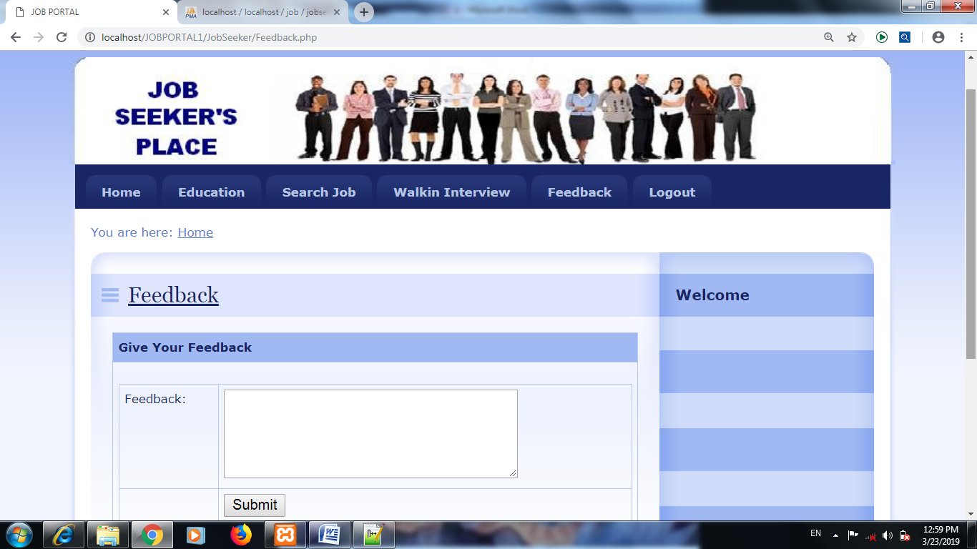

## 

## CHAPTER -6

**ADVANTAGES AND DISADVANT**

Advantages-

The system is very simple in design and to implement. The system requires very low system resources .

* 1. User Friendly Application
  2. Open Source Application
  3. Secure Database
  4. Simple Coding Techniques
  5. Easy Maintenance
  6. Fast processing and handy
  7. System reduces manual workload
  8. Redundancy of data is avoided
  9. Provides report of data

Disadvantages

1. Report cannot be downloaded

2. The SMS Facility is not available

3. Faculty login is not there.

**6.2 CONCLUSION:**

The purpose and the objective of the project is achieved. By providing graphical user interface, webpage designing is easy in aesthetic form. Flexibility in designing makes user explore their imagination and accomplish their wish of web designing. A web based design visualization of all the details of the college website has been created. Interactive location has been created to a college website because they explain a lot about the every single components of the project. A trend of utilizing the power of the geospatial Knowledge through the World Wide Web to disseminate the useful information of a project site.

**6.3 Future Scope:**

The website can be implemented under various situations. We can add new features as and when require. Reusability is possible as and when require in this application. There is flexibility in all the modules. The new effects and design can also be implemented in the website. There could be new website generated as well as add or reduced the tabs in the new version. We can also provides job seeker sms facility.

**6.4 REFERENCES:**

The following websites are preferred

**https://www.google.co.in**

**https://www.tutorialspoint.com**

**https://www.w3schools.com**

**https://en.wikipedia.org**

S